Waiver/Registration
I understand that winter walking can be a potentially dangerous activity. I will not enter WALK FOR WARMTH unless I am medically able. I agree to abide by any decision of a WALK FOR WARMTH official relative to my ability to safely complete the walk. I assume all risks associated with walking in this event including, but not limited to, falls, contact with other participants, effects associated with the weather such as low temperatures and/or humidity, traffic and the conditions of the road—all such risks being known and assumed by me. I grant permission to the Cheboygan County United Way to use photographs taken of me at the 2020 WALK FOR WARMTH to be used in agency publications and press material. Having read this waiver and photo release and knowing these facts and in consideration of your accepting my entry, I for myself and anyone entitled to act on my behalf, waive and release the Cheboygan County United Way, the City of Cheboygan, and all sponsors, their representatives, successors and all WALK FOR WARMTH committee members from all claims or liabilities of any kind arising out of my participation in this event.

Walker’s Signature:

Parent/Guardian Signature:
(For walkers under the age of 18)
Date:
Registration forms may be dropped off at Straits Area Federal Credit Union or the United Way. Please make all Checks payable to the Cheboygan County United Way c/o Cheboygan W4W. If you would like to pay by credit card, please contact the Cheboygan County United Way.
Sharing the Warmth of Our Community!

Name:
Team/Group Name:
(For those collecting pledges as a team)
Address: __________________________________
Phone:
E-mail:
(E-mail will only be used to contact you about Walk for Warmth events)

Walk Fee* ($5 minimum donation or pledge): $
* Walk Fee is considered a donation and is non-refundable. If event must be
canceled, Walk Fee will not be refunded.

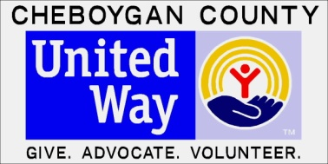

Cheboygan County United Way
520 N. Main St. Suite 106 Cheboygan, MI 49721
(231) 627-2288 or (231) 627-2062
Fax: 855-313-0181
ccuw@hotmail.com
David Martin, Event Coordinator

